Name:

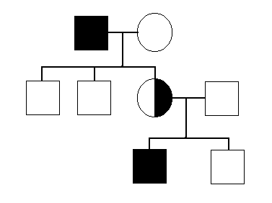Biology 1 Name:

***Pedigree Internet***  Date:

Assignment Hour:

Go to: <http://www.zerobio.com/drag_gr11/pedigree/pedigree_overview.htm>

Look at the menu that runs along the top of the page. Click on the appropriate heading.

***Tongue Rolling:***

Draw the completed pedigree:

Answer the questions:

1.

2.

3.

4.

***Eye Color:***

Draw the completed pedigree:

Answer the questions:

1.

2.

3.

4.

5.

***Diabetes:***

Draw the completed pedigree:

Answer the questions:

1.

2.

3.

4.

***Hypertension:***

Draw the completed pedigree:

Answer the questions:

1.

2.

3.

4.

**5.**