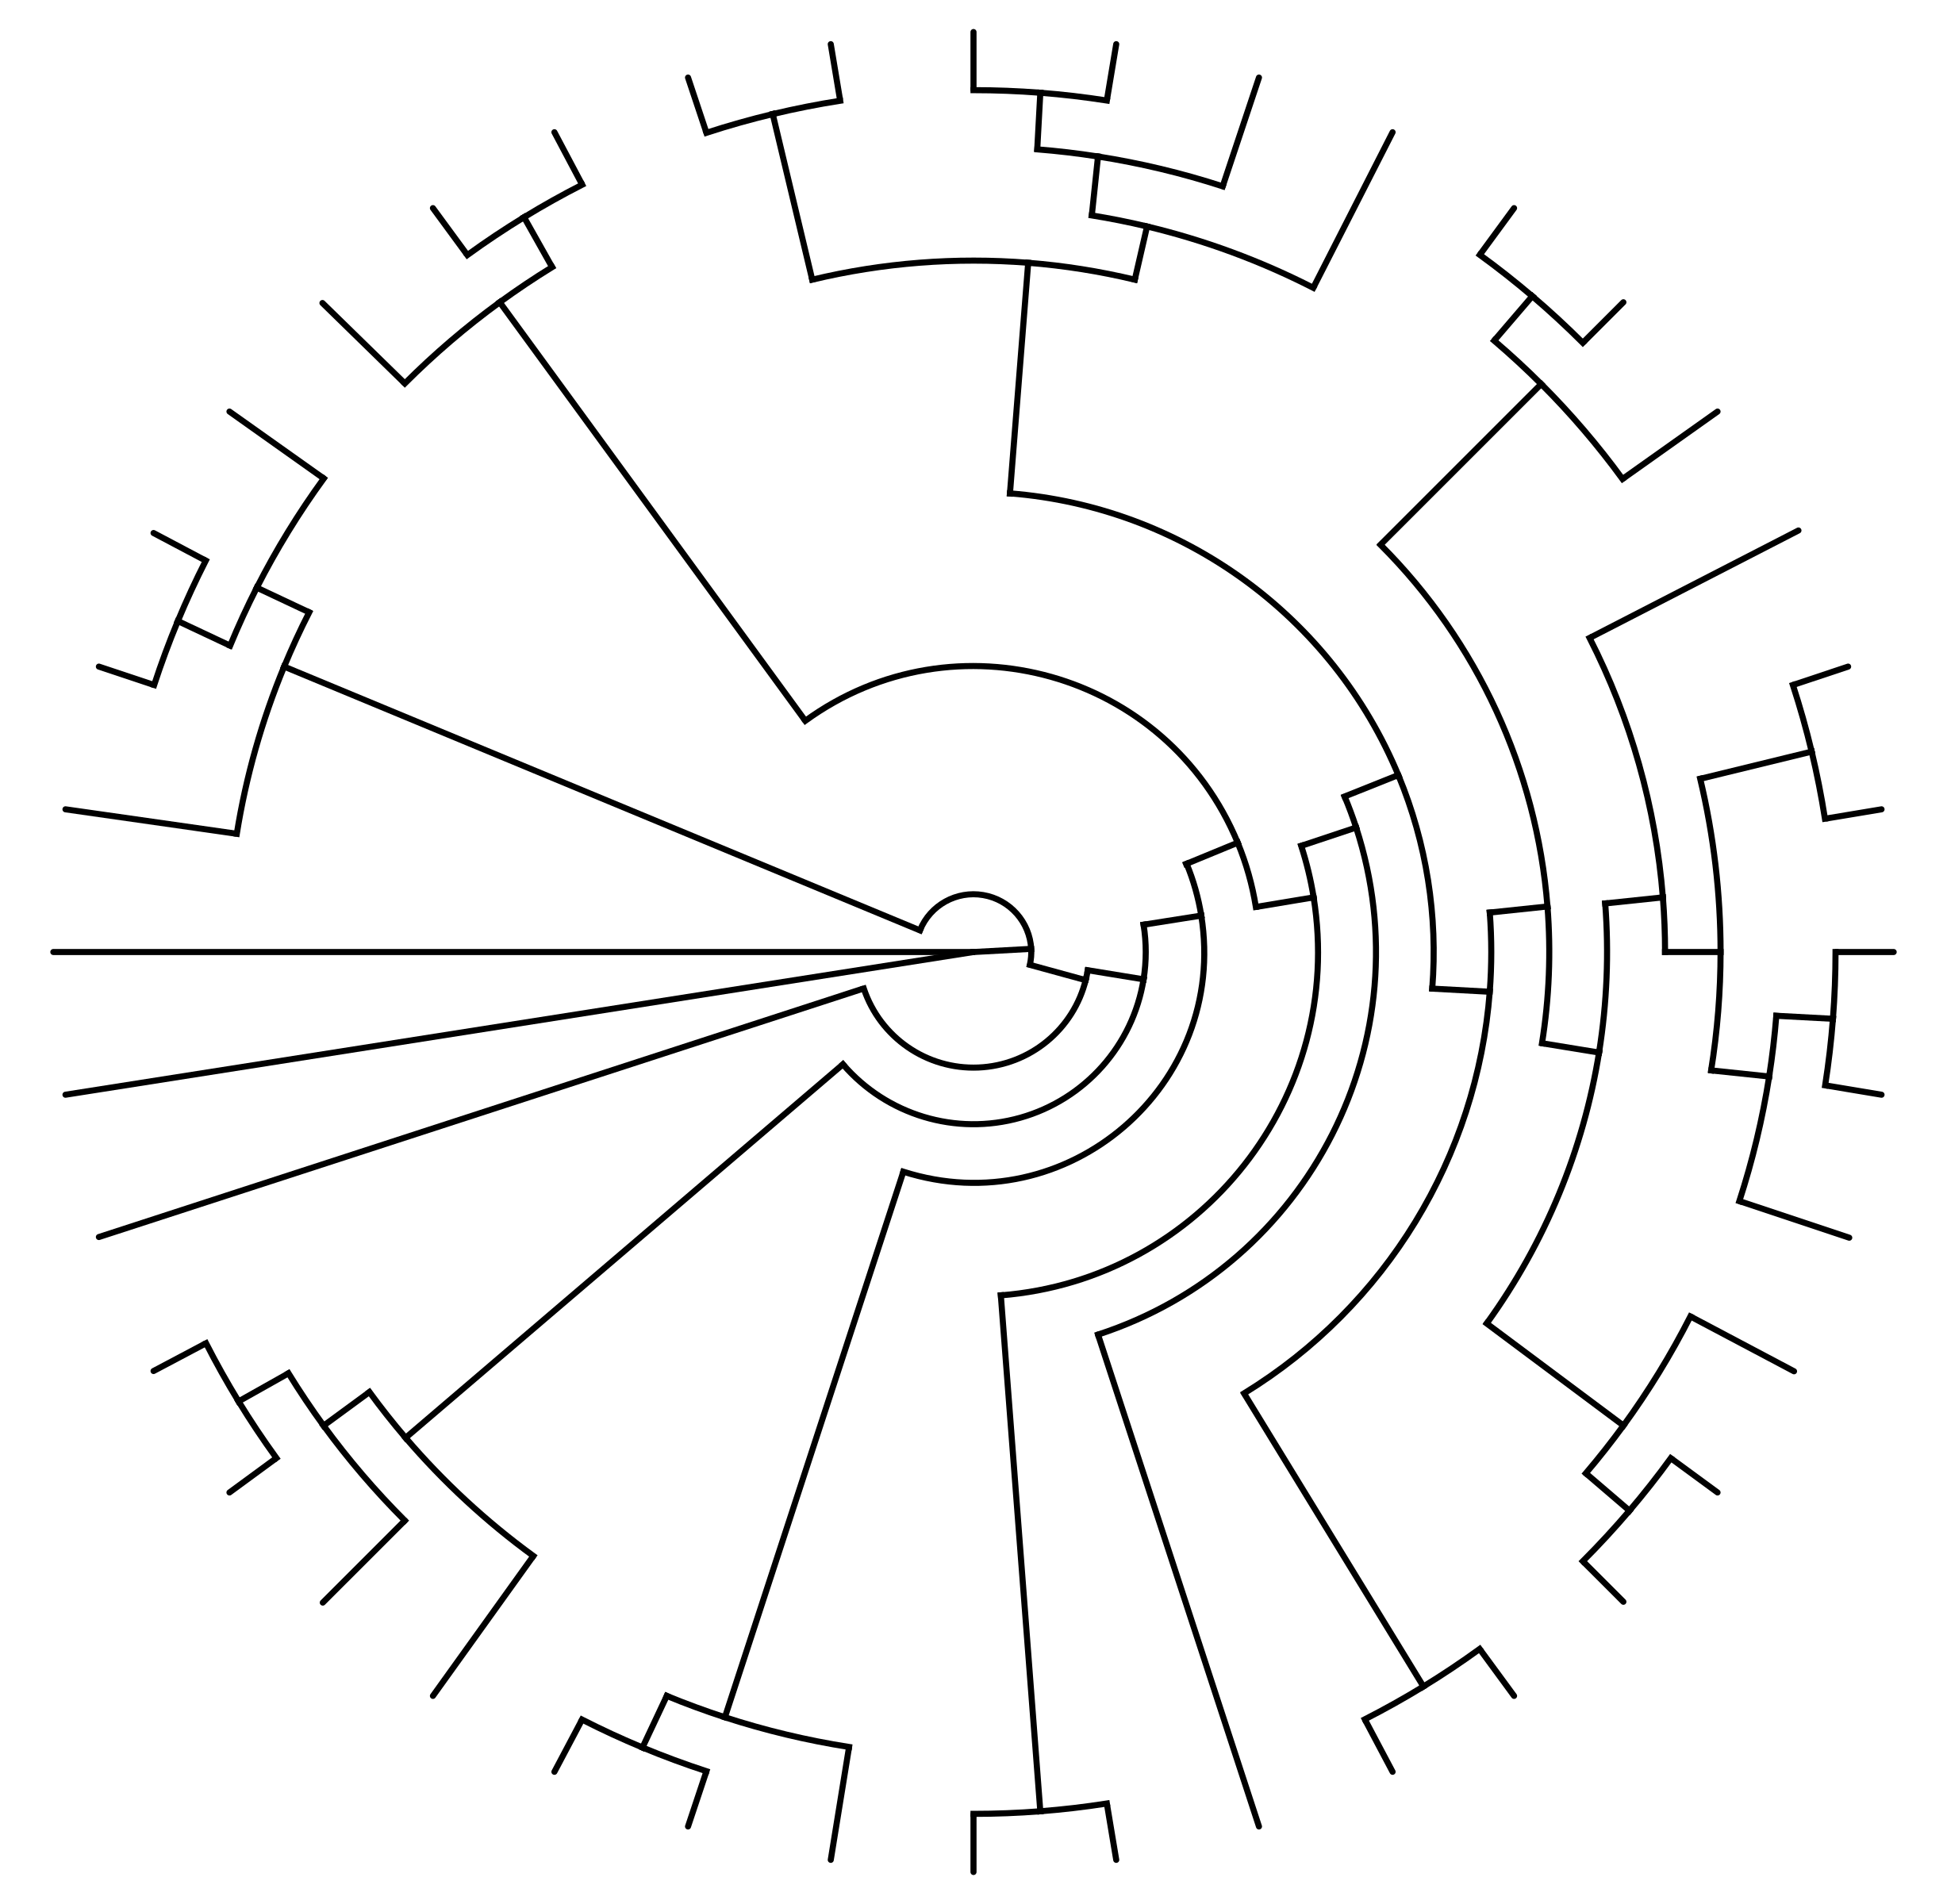
Biology 1 Name:
Odd One Out Date:
Classification Activity Hour:

Table | Odd One Out | Reasoning
1

2

3

4

5
6
7

