Biology 1 Name
Experimental Design Worksheet Date
Hour
Read the statements next to each picture. Determine if the statement in an observation or an inference. If the statement is an observation, you must distinguish between qualitative and quantitative. Circle your answer.
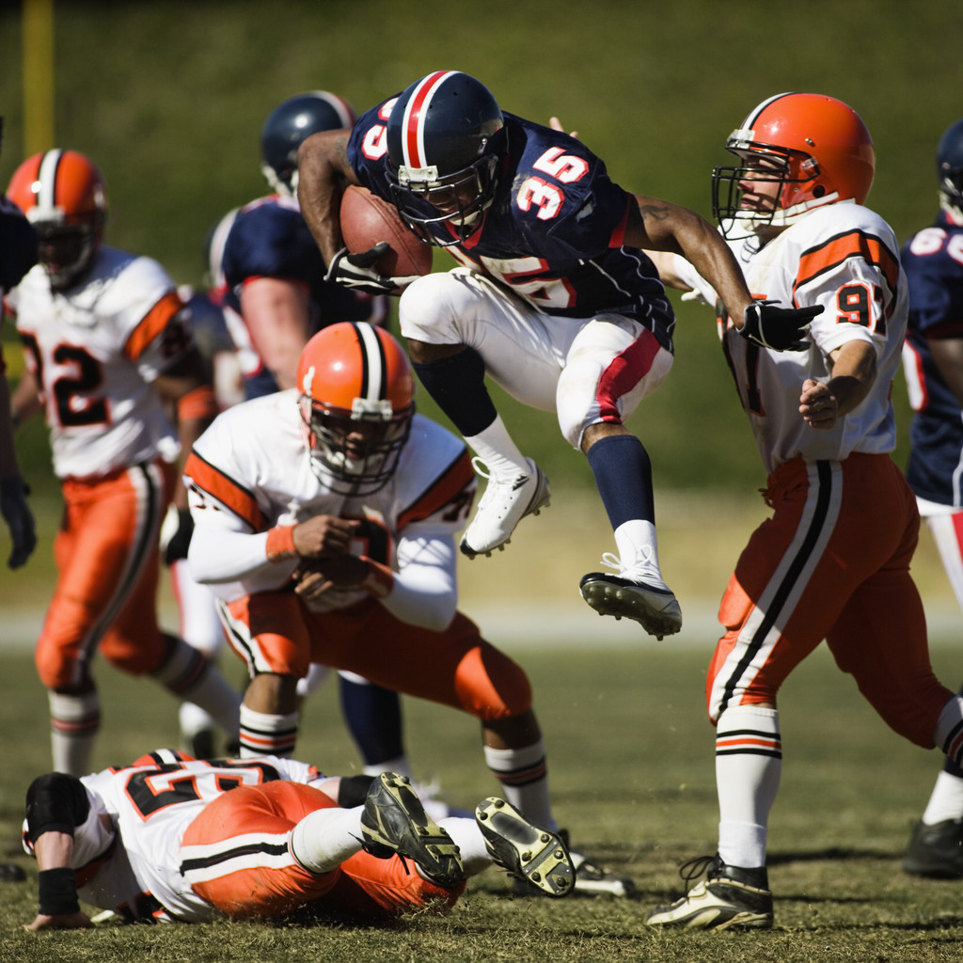
1. There are three players from the white team
surrounding the ball carrier.

Qualitative Observation Quantitative Observation Inference

2. Number 35 on the black team is very good because
he is hard to catch.

Qualitative Observation Quantitative Observation Inference

3. The white team is about to lose the game.

Qualitative Observation Quantitative Observation Inference

4. The player with the ball is jumping.

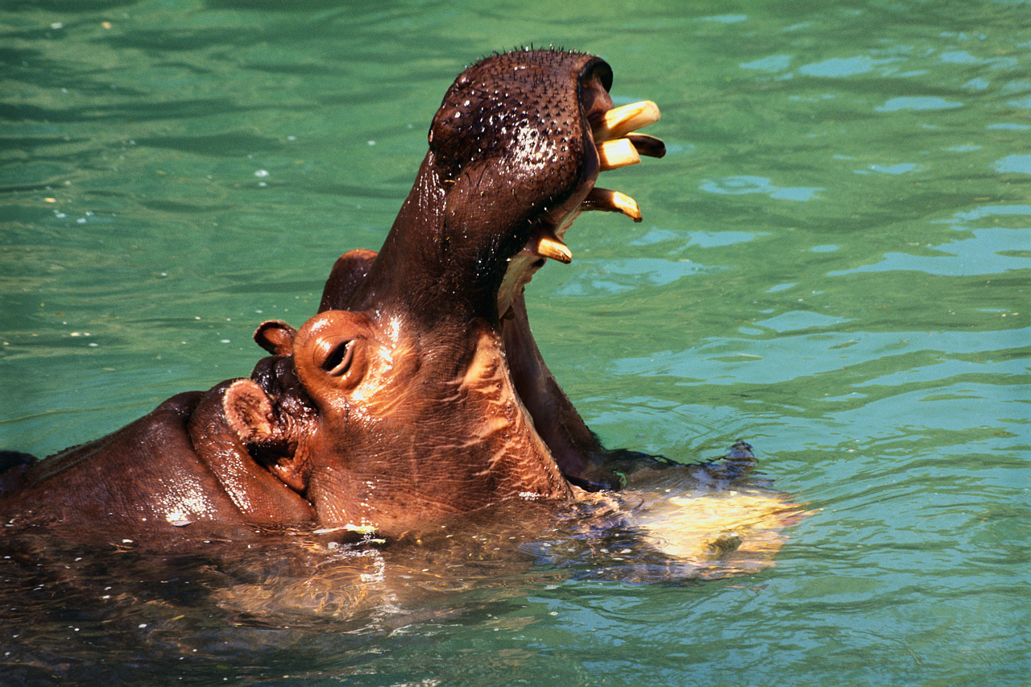
Qualitative Observation Quantitative Observation Inference

5. This hippo is a hungry, hungry hippo.

Qualitative Observation Quantitative Observation Inference

6. The hippo’s bottom teeth are larger than its upper
teeth.

Qualitative Observation Quantitative Observation Inference

7. The hippo has wrinkled skin.

Qualitative Observation Quantitative Observation Inference
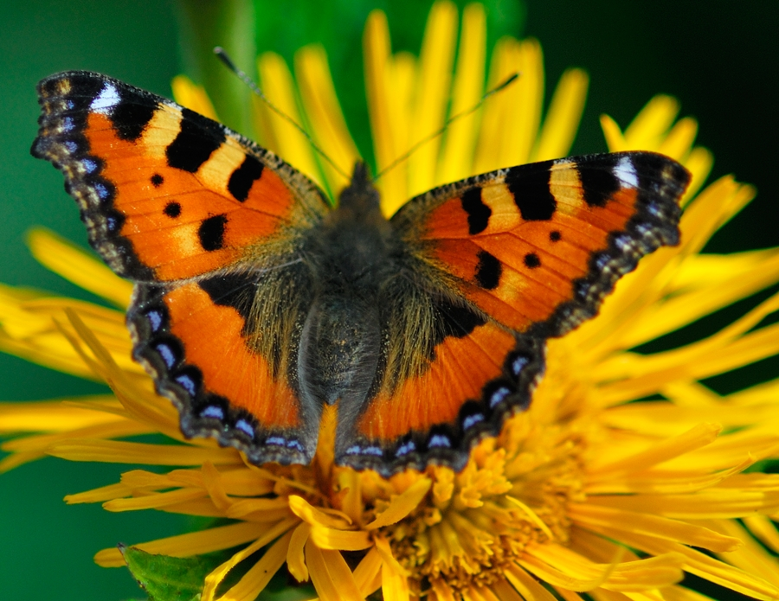
8. The butterfly’s wings both have similar patterns on them.

Qualitative Observation Quantitative Observation Inference

9. The butterfly just emerged from a cocoon.

Qualitative Observation Quantitative Observation Inference

10. Without the butterfly to spread the plant’s pollen,
the plant would not survive.

Qualitative Observation Quantitative Observation Inference
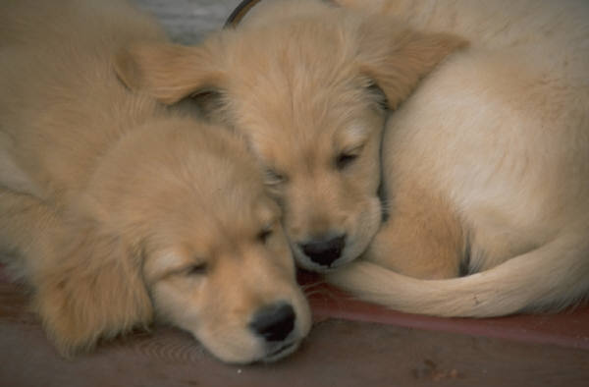
11. The butterfly’s body is mostly dark with smaller,
lighter stripes.

Qualitative Observation Quantitative Observation Inference

12. There are two puppies lying down.

Qualitative Observation Quantitative Observation Inference

13. The puppies are so cute.

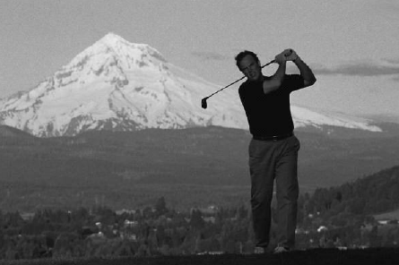
Qualitative Observation Quantitative Observation Inference
14. One puppy is curled up because he is cold.

Qualitative Observation Quantitative Observation Inference

15. This guy is golfing near Mt. Everest.

Qualitative Observation Quantitative Observation Inference

16. The golfer is not very happy with his last shot.

Qualitative Observation Quantitative Observation Inference

17. The man is holding a golf club.

Qualitative Observation Quantitative Observation Inference

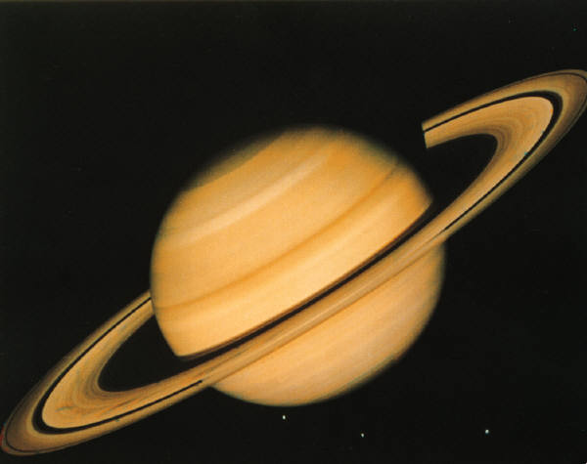
18. This planet must be Saturn because it has rings.

Qualitative Observation Quantitative Observation Inference

19. The planet is striped and has striped rings around it.

Qualitative Observation Quantitative Observation Inference

20. This picture was taken by a satellite as it passed
Saturn.

Qualitative Observation Quantitative Observation Inference

