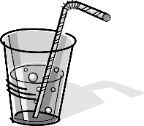
Biology 1 Name:
Exercise and Cellular Respiration Date:
Investigation Hour:

Develop a model to describe how food is rearranged through chemical reactions forming new molecules that support growth and/or release energy as this matter moves through an organism.

I. Background Information.
Cellular respiration (see chemical reaction below) is a chemical reaction that occurs in your cells to create energy; when you are exercising, your muscle cells are creating ATP to contract. Cellular respiration requires oxygen (which is breathed in) and creates carbon dioxide (which is breathed out).

This lab will address how exercise (increased muscle activity) affects the rate of cellular respiration. You will measure 3 different indicators of cellular respiration: breathing rate, heart rate, and carbon dioxide production. You will measure these indicators at rest (with no exercise) and after 1 and 2 minutes of exercise. Breathing rate is measured in breaths per minute, heart rate in beats per minute, and carbon dioxide in the time it takes bromothymol blue to change color. Carbon dioxide production can be measured by breathing through a straw into a solution of bromothymol blue (BTB). BTB is an acid indicator; when it reacts with acid it turns from blue to yellow. When carbon dioxide reacts with water, a weak acid (carbonic acid) is formed (see chemical reaction below).

The more carbon dioxide you breathe into the BTB solution, the faster it will change color to yellow.

II. Purpose.
• To observe the effects of exercise on cellular respiration.
• To identify the role of carbon dioxide production, breathing rate, and heart rate in determining the rate of cellular respiration.

III. Pre-Lab. Use your background information AND your Cellular Respiration notes to answer the following
1. What is the equation for cellular respiration? Label the reactants and the Products.

2. In what part of the cell does cellular respiration occur?

3. Write a prediction/hypothesis of how exercise will affect your body’s production of carbon dioxide (i.e. do you think your body will produce more or less carbon dioxide as you exercise). Make sure you EXPLAIN WHY.

IV. Materials:
• Beaker/Test Tube/Cup/Flask
• bromothymol blue solution (BTB) + Dropper
• straw
• stop watch

V. Safety:
• Always have an adult with you to help you during your experiment.
• Always wear eye protection working with chemicals. The individual blowing into the test solution should were safety glasses. Avoid splashing the solution.
• Conduct this experiment in an area where exercise can be done safely.

I. Procedure:

PART A: Resting (no exercise)

Measuring Carbon Dioxide Production:
1. Use a graduated cylinder to measure out ____ mL of tap water and pour it into a small beaker.
2. Use a dropper to add ____ drops of bromothymol blue to make a BTB solution.
3. Using a straw, exhale into the BTB solution. (CAUTION: Do not inhale the solution!)
4. Time how long it takes for the blue solution to turn yellow. Record the time in Table 1.
5. Wash out the beaker repeat steps 1-4 twice more.
6. Average the results of the 3 trials. Record this in Table 1.

Measuring Breathing Rate:
1. Count the number of breaths (1 breath = inhale + exhale) you take in 1 minute. Record this in Table 2.
2. Repeat this 2 more times.
3. Average the 3 trials to get your average breathing rate. Record this in Table 2.
Measuring Heart Rate:
4. While you calculate your breathing rate, have your partner take your pulse.
5. Count the number of beats in 30 seconds and multiply that number by 2. Record this in Table 3.
6. Repeat this 2 more times.
7. Average the 3 trials to get your average heart rate. Record this in Table 3.

PART B: Increased Muscle Activity (Exercise)

1. Exercise for exactly 1 minute by doing jumping jacks, light jogging or another activity.
2. While you are exercising, your partner should get the BTB solution ready as in Part A.
3. After 1 minute of exercise, immediately exhale through the straw into the BTB solution. Time how long it takes for the BTB to turn yellow. Record this in Table 1.
4. Then quickly calculate your breathing and heart rates as you did before. You only need to do this once.
5. Record these values in Tables 2 & 3. Remake your BTB solution.
6. Exercise as you did before, but for 2 continuous minutes.
7. Immediately exhale through the straw into the BTB solution. Time how long it takes for the BTB to turn yellow. Record this in Table 1.
8. Then quickly calculate your breathing and heart rates as you did before. You only need to do this once.
9. Record these values in Tables 2 & 3.
10. If there is time, repeat the entire procedure for your lab partner. Record data from 2 OR 3 other subjects in the class to get more data depending on if you partner was able to go or not.
VII. Data and Observations:
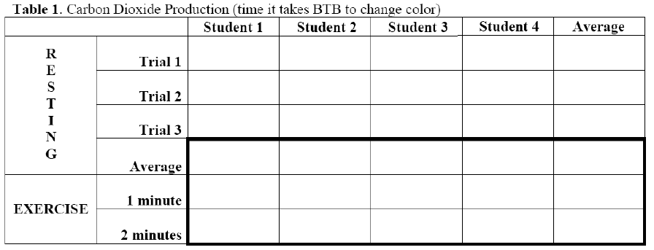

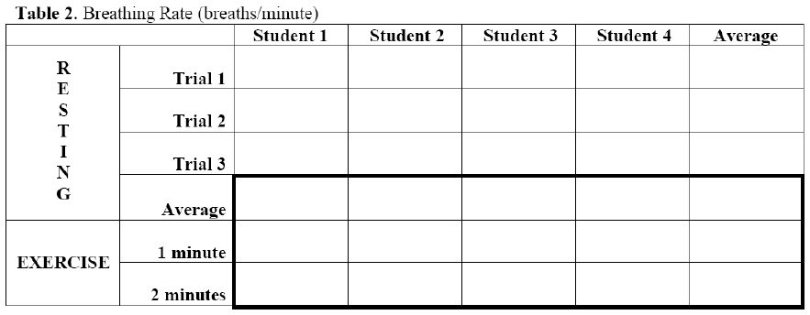

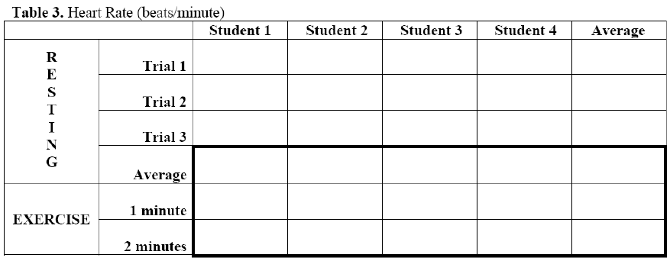

VIII. Conclusion Questions:

Answer the questions below using your BACKGROUND information in the lab, as well as your lab data. ANSWER THE QUESTIONS IN COMPLETE SENTENCES.

1. How did exercise affect the time needed for the solution to change color? Explain why the color change occurred (How does BTB work?)

2. What can you conclude about the effect of exercise on the amount of carbon dioxide that is present in your exhaled breath? Why is this so?

3. Make a small graph of average time need to change indicator vs. amount of exercise below:

4. What can you conclude about the effect of exercise on breathing rate? Why is this so?

5. Make a small graph of average breathing rate vs. amount of exercise below:

6. What can you conclude about the effect of exercise on heart rate? Why is this so? What do your muscles need during exercise that the blood brings?

7. Make a small graph of average heart rate vs. amount of exercise below:

8. State whether your hypothesis was correct or incorrect and why. In doing so, discuss what you think is going on in the muscles of the body as muscle activity is increased. Address the need to get oxygen to the muscles and get rid of carbon dioxide, as well as how the muscles cells get the energy needed to continue contracting. What did you see? Anything you were not expecting? Something amazing? Describe it here.

References:
Adapted from: Exercise and Cellular Respiration Lab. Central Bucks School District. http://www1.cbsd.org/sites/teachers/hs/ESCOTT/Documents/Unit%205%20-%20Photosynthesis%20and%20Respiration/Exercise_Cellular_Respiration_lab.pdf (Aug 1, 2013).
Adapted by: California State University of Bakersfield, Department of Chemistry

