**ATOM_1Biology 1**

***Elements & Macromolecules in Organisms*** Name

Date

Hour

# Most common elements in living things are carbon, hydrogen, nitrogen, and oxygen. These four elements constitute about 95% of your body weight. All compounds can be classified in two broad categories --- organic and inorganic compounds. Organic compounds are made primarily of carbon. Carbon has four outer electrons and can form four bonds. Carbon can form single bonds with another atom and also bond to other carbon molecules forming double, triple, or quadruple bonds. Organic compounds also contain hydrogen. Since hydrogen has only one electron, it can form only single bonds.

Each small organic molecule can be a unit of a large organic molecule called a **macromolecule.** There are **four classes of macromolecules** (polysaccharides or **carbohydrates**, triglycerides or **lipids**, polypeptides or **proteins**, and **nucleic acids** such as DNA & RNA). **Carbohydrates and lipids** are made of only carbon, hydrogen, and oxygen **(CHO**). **Proteins** are made of carbon, hydrogen, oxygen, and nitrogen **(CHON).** **Nucleic acids** such as DNA and RNA contain carbon, hydrogen, oxygen, nitrogen, and phosphorus **(CHON P).**

Use the drawing of the **amino acid on this worksheet** (look ahead to another page for this sketch and remember that the NUMBER OF LINES from a single atom is their NUMBER OF BONDS) to determine the number of bonds formed by:

\_\_\_\_\_\_ Oxygen \_\_\_\_\_\_\_Hydrogen \_\_\_\_\_\_\_ Nitrogen

The body also needs trace amounts of other elements such as calcium, potassium, and sulfur for proper functioning of muscles, nerves, etc. ***Color*** each of the **elements on the next page** according to the color listed next to the element's symbol. Then ***Color code*** the **squirrel** with the correct proportion of each element's color. Now ***color code*** the carrot with the same colors as you used on the squirrel.

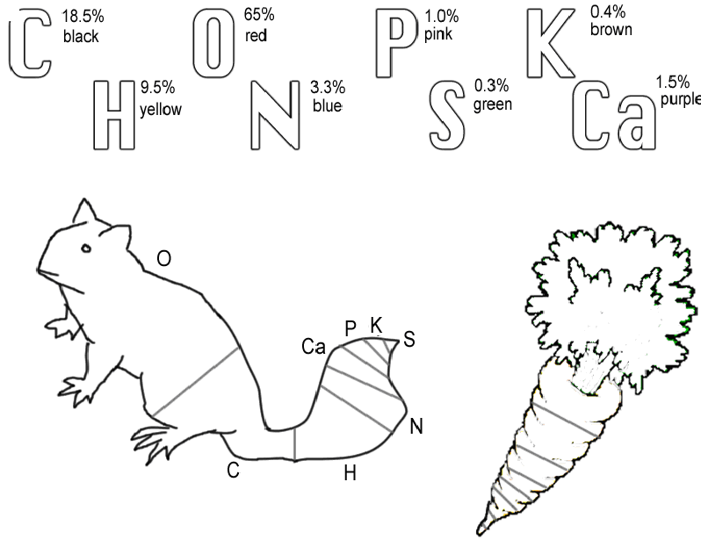

# *Questions:*

# 1. Name the 4 main elements that make up 95% of an organism.

# 2. Name the 4 types of bonds carbon can form.

# 3. What are macromolecules?

# 4. Name the 4 classes of macromolecules.

# 5. Give 2 examples of nucleic acids.

# 6. What elements make up carbohydrates & lipids (symbols)?

# 7. Name 3 elements your body needs trace amounts of for proper functioning.

# The four main classes of organic compounds (carbohydrates, lipids, proteins, and nucleic acids) that are essential to the proper functioning of all living things are known as polymers or macromolecules. All of these compounds are built primarily of carbon, hydrogen, and oxygen but in different ratios. This gives each compound different properties.

# Carbohydrates are used by the body for energy and structural support in cell walls of plants and exoskeletons of insects and crustaceans. They are made of smaller subunits called monosaccharides. Monosaccharides have carbon, hydrogen, and oxygen in a 1:2:1 ratio. Monosaccharides or simple sugars include glucose, galactose, and fructose. Although their chemical formulas are the same, they have different structural formulas. These simple sugars combine to make disaccharides (double sugars like sucrose) and polysaccharides (long chains like cellulose, chitin, and glycogen). *Color code* the glucose molecule on this worksheet (carbon-black, hydrogen-yellow, and oxygen-red). Use your textbook to help *draw* the structural formulas for fructose and galactose: (p55)

# Fructose: Galactose:

***Use the diagram of glucose*** to tell how many carbons, hydrogens, and oxygens are in a single molecule.

# #C \_\_\_\_\_\_\_\_\_\_ # H \_\_\_\_\_\_\_\_\_\_ # O \_\_\_\_\_\_\_\_\_\_

# *Glucose Molecule*

**O**

**C**

**C**

**C**

**C**

**C**

**O**

**H**

**H**

**C**

**H**

**H**

**O**

**H**

**H**

**H**

**O**

**H**

**H**

**O**

**H**

**H**

**O**

**H**

# *Questions:*

# 8. Macromolecules are also known as \_\_\_\_\_\_\_\_\_\_\_\_\_.

# 9. If all the macromolecules are made mainly of the elements CHO, how are they different?

# 10. Name 2 ways your body uses carbohydrates.

# 11. What are the subunits called that make up carbohydrates?

# 12. What is the ratio of C, H, and O in monosaccharides?

# 13. Name 3 monosaccharides.

# 14. Monosaccharides are \_\_\_\_\_\_\_\_\_\_\_ sugars.

# 15. What are disaccharides & give an example?

# 16. Long chains of sugars are \_\_\_\_\_\_\_\_\_\_\_\_\_\_. Name three.

# Proteins are made of subunits called amino acids and are used to build cells and do much of the work inside organisms. They also act as enzymes helping to control metabolic reactions in organisms. Amino acids contain two functional groups, the carboxyl group (-COOH) and the amino group (-NH2).

# Use your textbook and sketch the amino and carboxyl groups. (p56)

# Amino group Carboxyl group

# *Color code* the amino acid on this worksheet (carbon-black, hydrogen-yellow, nitrogen-blue, and oxygen-red).

# Basic Structure of Amino acid

**N**

**H**

**H**

**C**

**C**

**O**

**H**

**H**

**R group**

# 

# Enzymes are protein molecules that act as biological catalysts. Cells contain thousands of different enzymes to control the functions of the cell. Enzymes must physically fit a specific substrate(s) to work properly. The place where a substrate fits an enzyme to be catalyzed is called the active site. Excess heat, a change in pH from neutral, etc. change the shape of enzymes and their active sites so the enzyme is unable to work. Some enzymes have a second site where a coenzyme attaches to help make the substrate better fit the active site of the enzyme. *Color* the enzyme purple, the substrate yellow, and the coenzyme green. Also *color* the active site red.

# enzymes2

# Enzyme-Substrate Complex

# Condensation (removal of a water molecule) links amino acids link together to form chains called polypeptides. Polypeptide chains join to form proteins. The bonds holding amino acids to each other are known as peptide bonds. *Use your textbook* to make a sketch of a dipeptide (2 amino acids linked with a peptide bond) molecule. (p59)

# Dipeptide Sketch:

# *Questions:*

# 17. What subunits make up proteins?

# 18. Proteins also act as \_\_\_\_\_\_\_\_\_\_ in cells to control reactions.

# 19. Name the 2 functional groups in amino acids.

# 20. Cells have \_\_\_\_\_\_\_\_ of enzymes to act as biological \_\_\_\_\_\_\_\_\_\_.

# 21. Enzymes have an attachment site called the \_\_\_\_\_\_\_\_\_\_ site for the \_\_\_\_\_\_\_\_\_\_ to join.

# 22. What is the effect of excess heat or temperature on an enzyme?

# 23. Amino acids are linked together to make proteins by removing a molecule of \_\_\_\_\_\_\_\_ in a process called \_\_\_\_\_\_\_\_\_\_\_\_.

# 24. Chains of amino acids make \_\_\_\_\_\_\_\_\_\_\_\_\_\_\_ which can join together to make a \_\_\_\_\_\_\_\_\_\_.

# 25. \_\_\_\_\_\_\_\_\_\_ bonds form when water is removed to hold \_\_\_\_\_\_\_\_\_ acids together.

# Lipids are large, nonpolar (won't dissolve in water) molecules. Phospholipids make up cell membranes. Lipids also serve as waxy coverings (cuticle) on plants, pigments (chlorophyll), and steroids. Lipids have more carbon and hydrogen atoms than oxygen atoms. Fats are made of a glycerol (alcohol) and three fatty acid chains. This subunit is called a triglyceride. *Color* the glycerol molecule using the same colors for carbon, hydrogen, and oxygen as you did before. The fatty acid chains may be saturated (only single bonds between carbons) or unsaturated (contain at least one double bond). A carboxyl functional group (-COOH) is found on the end of the fatty acid that does NOT attach to glycerol. *CIRCLE AND LABEL* the carboxyl groups in the 2 fatty acids on this worksheet. *Color* the fatty acid chains the same colors for carbon, hydrogen, and oxygen as you did before. A special type of lipid called phospholipids help make up the cell membrane. Two layers of these phospholipids make up the membrane. Phospholipids have a "water-loving" hydrophilic head and two "water-fearing" hydrophobic tails. *Find* the cell membrane on this sheet and *CIRCLE AND LABEL* a phospholipid. Proteins are also embedded in the cell membrane. *Color* the two proteins in the cell membrane blue.

# Glycerol

**C**

**C**

**C**

**H**

**H**

**H**

**H**

**H**

**O**

**O**

**O**

**H**

**H**

**H**

# Saturated fatty Acid

**H**

**C**

**C**

**C**

**C**

**C**

**C**

**H**

**C**

**C**

**C**

**H**

**H**

**H**

**H**

**H**



**H**

**H**

**H**

**H**

**H**

**H**

**H**

**H**

**H**

**H**

**H**

**H**

**C**

**O**

**O**

**H**

# Unsaturated Fatty Acid - Double Bond

**H**

**C**

**C**

**C**

**C**

**C**

**C**

**H**

**C**

**C**

**C**

**H**

**H**

**H**

**H**

**H**



**H**

**H**

**H**

**H**

**H**

**H**

**H**

**H**

**H**

**H**

**H**

**H**

**C**

**O**

**O**

**H**

# Cell Membrane

# 

# *Questions:*

# 26. Lipids are nonpolar. What does this mean?

# 27. What WILL lipids (oils and fats) dissolve in? (Question for thought)

# 28. \_\_\_\_\_\_\_\_\_\_\_\_\_\_\_\_\_ makes up cell membranes.

# 29. Name a waxy lipid covering plants.

# 30. Plant pigments like \_\_\_\_\_\_\_\_\_\_\_\_\_\_ are also \_\_\_\_\_\_\_\_\_\_.

# 31. Lipids have more \_\_\_\_\_\_\_\_\_\_\_ and \_\_\_\_\_\_\_ than they do oxygen atoms.

# 32. Fats are made of an alcohol called \_\_\_\_\_\_\_\_\_\_ and three \_\_\_\_\_\_\_\_\_\_ \_\_\_\_\_\_\_\_\_ chains. This is known as a \_\_\_\_\_\_\_\_\_\_\_\_.

# 33. If there are all SINGLE bonds between \_\_\_\_\_\_\_ in the fatty acid chain, then it is said to be \_\_\_\_\_\_\_\_\_\_\_\_.

# 34. If there is a DOUBLE bond between \_\_\_\_\_\_\_\_\_ in the fatty acid chain, then it is said to be \_\_\_\_\_\_\_\_\_\_\_\_.

# 35. The end of the fatty acid that does NOT attach to glycerol has what functional group? Write the formula for this group.

# 36. \_\_\_\_\_\_\_ layers of \_\_\_\_\_\_\_\_\_\_\_\_ make up the cell membrane.

# 37. The head of a phospholipid \_\_\_\_\_\_\_\_\_\_ water and is said to be \_\_\_\_\_\_\_\_\_\_\_\_\_\_.

# 38. The 2 tails of a phospholipid \_\_\_\_\_\_\_\_\_\_ water and is said to be \_\_\_\_\_\_\_\_\_\_\_\_\_\_.

# Nucleic acids carry the genetic information in a cell. DNA or deoxyribose nucleic acid contains all the instructions for making every protein needed by a living thing. RNA copies and transfers this genetic information so that proteins can be made. The subunits that make up nucleic acids are called nucleotides.

# *COLOR AND LABEL* the parts of a nucleotide --- sugar (5-sided)-green, phosphate group (round)-yellow, and nitrogen base (6-sided)-blue. ATP used for cellular energy is a high energy nucleotide with three phosphate groups. *Color* code the ATP and LABEL THE PHOSPHATES.

# Nucleotide

# ATP

# *Questions:*

# 39. Nucleic acids carry \_\_\_\_\_\_\_\_\_\_ information in a molecule called \_\_\_\_\_\_\_\_\_\_\_\_ or \_\_\_\_\_\_\_\_\_\_\_\_\_ \_\_\_\_\_\_\_\_\_\_\_ acid.

# 40. DNA has the instructions for making a cell's \_\_\_\_\_\_\_\_\_\_\_\_.

# 41. The nucleic acid \_\_\_\_\_\_\_\_\_ copies DNA so \_\_\_\_\_\_\_\_\_ can be made.

# 42. \_\_\_\_\_\_\_\_\_\_ are the subunits making up nucleic acid.

# 43. The 3 parts of a nucleotide are a 5 carbon \_\_\_\_\_\_\_\_, a phosphate, and a nitrogen \_\_\_\_\_\_\_\_\_\_.

# 44. \_\_\_\_\_\_\_\_ is a high energy molecule made from a \_\_\_\_\_\_\_\_\_\_\_ with \_\_\_\_\_\_\_ phosphates.

# *Final Questions:*

# 1. Give the symbols for the elements that make up each of the following:

# \_\_\_\_\_\_carbohydrates \_\_\_\_\_\_lipids \_\_\_\_\_\_DNA \_\_\_\_\_\_proteins

# 2. Name the 4 classes of macromolecules & give a function for each.

# 3. Name the subunits that make up each of the macromolecules.

# 4. Enzymes can be denatured (unfolded) by what environmental factors?

# 5. What process is used to link amino acids together?

# 6. Name the bonds found between amino acids in a polypeptide chain.

# 7. Explain the difference between a disaccharide and a polysaccharide. Give an example of each.

# 8. What two functional groups are found in amino acids?

# 9. Why are enzymes important to organisms?

# 10. Name the subunit that makes up fats.

# 11. What alcohol is found in a triglyceride?

# 12. What is the difference between a saturated and unsaturated fatty acid?