Biology 1 Name:

Building the Best Bird Name:
Activity/Competition Hour:

INTRODUCTION:
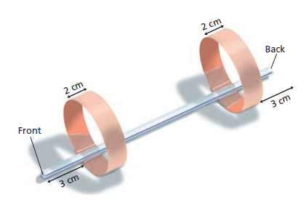
Your task is to build the best bird that you can based on the model pictured here. The best bird will be the one that is capable of flying/gliding the greatest distance when launched. There are two wings, at the posterior and anterior ends of the bird, which can be modified in three ways. You may change the position of the wing relative to the end of the bird, the circumference of the wing and wing width. You will be given the opportunity to create and test, at most, ten different birds. At the end of the allotted testing time, you will submit your final and best designed bird for evaluation. The creators of the bird that flies the farthest will be declared the winners of this competition.
Posterior Wing
Anterior Wing
IMPORTANT: You may only change one “variable” to create each new “bird”. You must highlight the change in your data table to show which variable you can contribute the increased or decreased flight distance to. You may change one variable (such as diameter of the front wing) more than once, but you may only make one change from one design to the next.

DATA:

Anterior Wing (cm) |  |  | Posterior Wing (cm) |  |  | Test Flights |  |  | Average Distance  (______)
Distance to Front | Width | Diameter | Distance to Back | Width | Diameter | 1 | 2 | 3
3 | 2 | 5 | 3 | 2 | 5

CONCLUSIONS:

Answer the following questions on the back of this paper
- If the “birds” you were creating were real, and survival was based on ability for fly far, what characteristics would likely be passed on to future generations? (Describe the characteristics that lead to better flight.)
- What would happen to the birds with little to no flight ability in the wild?
- In this activity, the selection criterion was flight distance. List at least three real organisms and the characteristic(s) that likely help them to survive and reproduce.
- Define the terms “natural selection” & “fitness”.
- Define “mutation”.
- What properties were being “mutated” in this activity?
- In nature, mutations happen randomly and can be beneficial, harmful or inert. Were all the mutations that you tried in this activity beneficial? Explain.
- Write 3-6 sentences describing how this activity relates to evolution.

