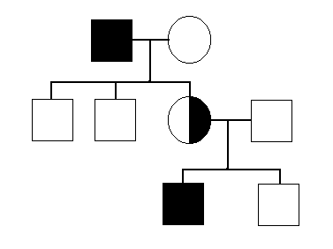Biology 1 Name:

***3 Pedigrees***  Date:

Worksheet Hour:

1. An Easy Pedigree

Trait:

R = tongue roller

r = non-roller

Parents: Father is a roller

Mother is a non-roller

Children: Boy1 is a roller

Boy 2 is a roller

Girl 3 is a non roller

Can you figure out the genotype of every person in this family?

Draw the pedigree below and be sure to include the genotypes of each individual.

2. Another Easy Pedigree

Trait:

E = normal - two eyes

e = cyclops - one eye in the middle of the head

Parents: Father “Ee”

Mother is “Ee”

Children: Girl 1is “EE”

Girl 2 is “Ee”

Boy 3 is “ee”

Boy 4 is “ee”

Draw the pedigree below. Be sure to color in the individuals that show the trait.

Biology 1 Name:

***Practice Pedigree***  Date:

Worksheet Hour:

Complete a pedigree for the following family. Remember to label *male, female, affected and carrier*. *Include each person’s name and genotype* as well.

Trait: Methemoglobinemia

B = normal

b = Blue skin

Jimbo married Marge:

-Jimbo (normal)

-Marge (blue)

Their Children:

-Jimbo Jr. (blue)

-Ralph (normal)

-Herbert (normal)

-Melvin (normal)

Herbert married Hannah:

-Hannah (normal)

Their Children:

-Helga (normal)

-Herbert Jr. (normal)

Jimbo Jr. Married Gertrude:

-Gertrude (normal)

Their Children:

-Jimbo III (normal)

-Gertie (normal)

-Gilbert (blue)

Herbert Jr. married Mimi

-Mimi (normal)

Their Children

-Fred (normal)

-Sally (normal)

-Joe (blue)

Complete the pedigree below. Be sure to include the names and the genotypes for each of the individuals.