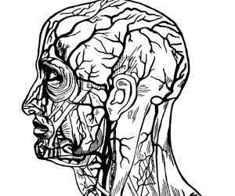
Biology 1 Information
Mr. Siemianowski
2019-2020

Contact Information

Mr. Siemianowski Room: 228
Eisenhower Phone: (586) 797-1300
E-mail: john.siemianowski@uticak12.org
(E-mail is preferred)

Electronic Notifications

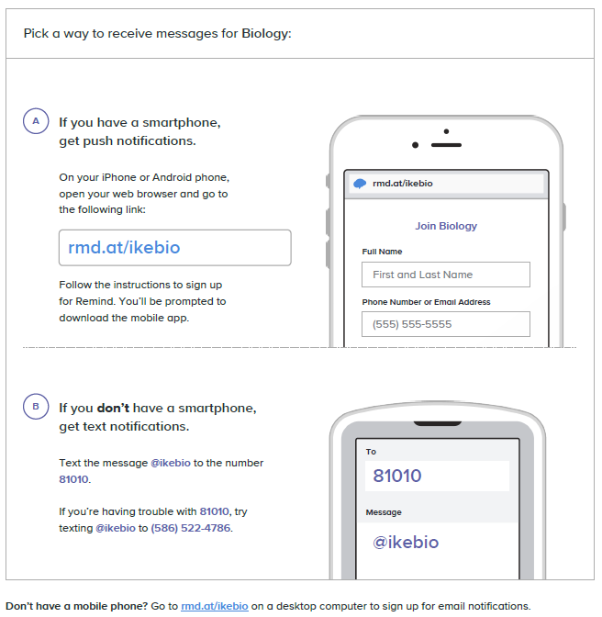

Online Class Access

siemianowski.weebly.com

This website includes a daily agenda (detailing what was done in class each day), an assignment section (with links to download all assignments), and a resources section (with notes, study guides and supplemental videos for extra help with content).

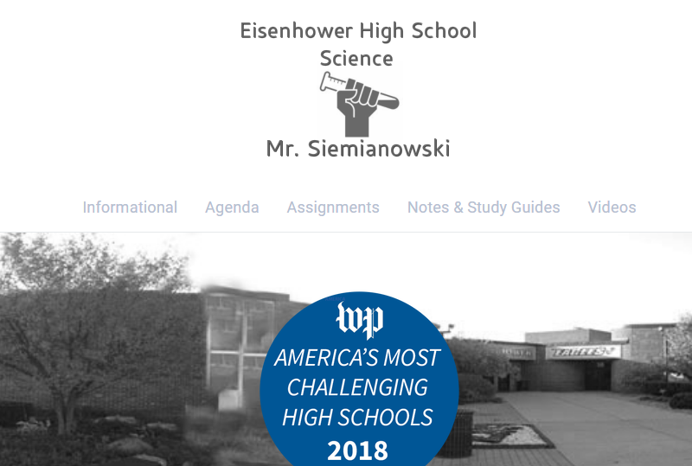

Online Grade Access

Access to student grades via Power School should alleviate issues or confusion over where any student stands academically. Grades will be updated approximately every other week. The website is listed below. User names and passwords are provided by the school. This information is available in the counseling office.

ps.ucs.misd.net/public
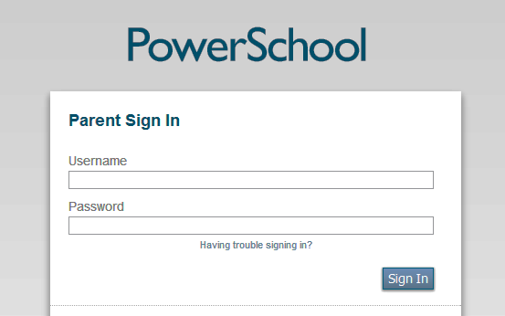

Grade Weight
Tests & Quizzes
Includes | Weight | Indicates
- formal assessments (tests & quizzes) | 60% | student mastery of material by answering questions without external resources
Labs & Projects
Includes | Weight | Indicates
- experiments  - investigations  - projects | 20% | student knowledge acquisition through application of concepts
Homework Completion
Includes | Weight | Indicates
- weekly grade base on completion (thoughtful attempts) of assigned homework | 10% | student effort to complete all assigned homework
Homework Comprehension
Includes | Weight | Indicates
- weekly grade from quizzes on material covered by assigned homework | 10% | *student understanding of the material covered by homework assignments through application of concepts
*students earning less than a 70% on any weekly homework quiz can make up the points needed to raise that grade to a 70% by completing the weekly make-up assignment on the class website - siemianowski.weebly.com

Letter Grade & Percent Grades Scale

Quarter and exam grades will adhere to the UCS grading scale. Semester grades are calculated according to the district 40/40/20 rule. (Qtr. 3/Qtr. 4/ exam)

A 94%-and above C 76%-73%
A- 93%-90% C- 72%-70%
B+ 89%-87% D+ 69%-67%
B 86%-83% D 66%-63%
B- 82%-80% D- 62%-60%
C+ 79%-77% F 59% and Below

Late/Make Up Work & Extra Help

- Late work is NOT accepted for credit.
- If students are absent, it is their responsibility to look at the class web site and either pick up or print any papers that are needed. Students will have to make time to come in before or after school to make up any assignments that cannot be made up at home. This would include tests and labs. PLEASE NOTE: Any work not submitted on the scheduled due date may not appear in PowerSchool until the last week of the marking period.
- Students should schedule time to come in to make up work or get extra help. In general, Mr. Siemianowski is available starting at 6:15am and through 2:45pm.

Extra Credit

Students with missing assignments are not eligible for extra credit. Students may raise their overall grade a maximum of 10% with extra credit. There are two options for extra credit that are detailed on the class website (extra credit section).
- Students may complete and turn in missing work (assignment grade still factored into overall grade as a zero), to open up the option of extra credit.
Extra credit is only entered twice a marking period. All extra credit will be entered only at progress report and report card times.

Homework Credit Guidelines

· Unless otherwise noted, homework assigned during one class period should be considered due at the beginning of the next Biology class period.
· Credit for daily assignments will be based on completeness. Completeness refers to both quantity and quality of the attempt. Work lacking thoughtful answers or failing to address all parameters of the directions may be considered incomplete. Partial credit may be earned for some assignments if a sufficient or thoughtful attempt is evidenced. If 50% or less of an assignment is attempted, no credit will be earned.
· While the initial (stamped) attempt at an assignment is not generally scored for accuracy, it is in each student’s best interest to fix or correct the homework as it is reviewed in class. Completed homework assignments will be a valuable resource for use on weekly homework quizzes and will allow students to earn credit towards 10% of the Biology 1 quarter grade under the “Homework Completion” category.
· Weekly homework quizzes will consist of two questions. The first will directly reflect an answer or item found within an indicated homework assignment discussed that week. The second question will ask students to respond after considering a homework item and some “new” piece of information such as a graph or an opposing point of view. Each of the questions will be worth half the points for a total of 4-16 points. Students will complete homework quizzes during an allotted 10 minute period in class using only their own, personal homework assignment.
· Students that are absent on the day homework is assigned or stamped are responsible for finding out about the work, completing it (within the timeframe of UCS absence policies) and seeking out the teacher before/after class to secure credit for the missed assignment on their stamp sheet. If an absence occurs early in the week, it is acceptable to present the absent (not late) work for credit while a later assignment is being stamped. Every effort needs to be made to complete missed work by Friday to afford all necessary resources for the weekly homework quiz.
· Students that misplace, lose or destroy their weekly homework sheet will forfeit the points earned from stamps. Students without sheets will still have the opportunity to earn weekly points from Friday’s homework quiz.

Curriculum/Units of Study

- Develop a working knowledge of biological topics from the macro to the microscopic
- Develop useful biological laboratory techniques
- Understand the role of Biology in everyday life
- Recognize the strengths and limits of science
- Skeptically analyze situations and data
- Read and write detailed scientific reports and responses
- Be more prepared for the SAT
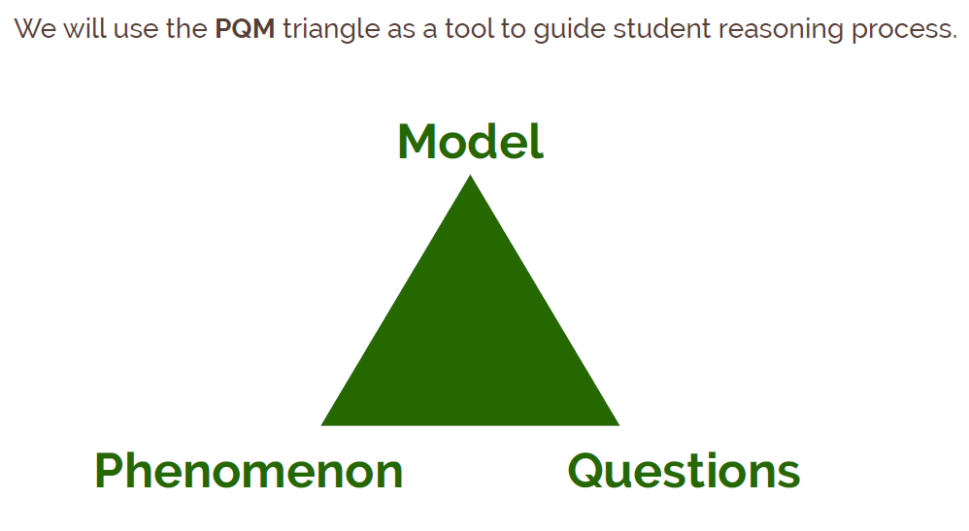

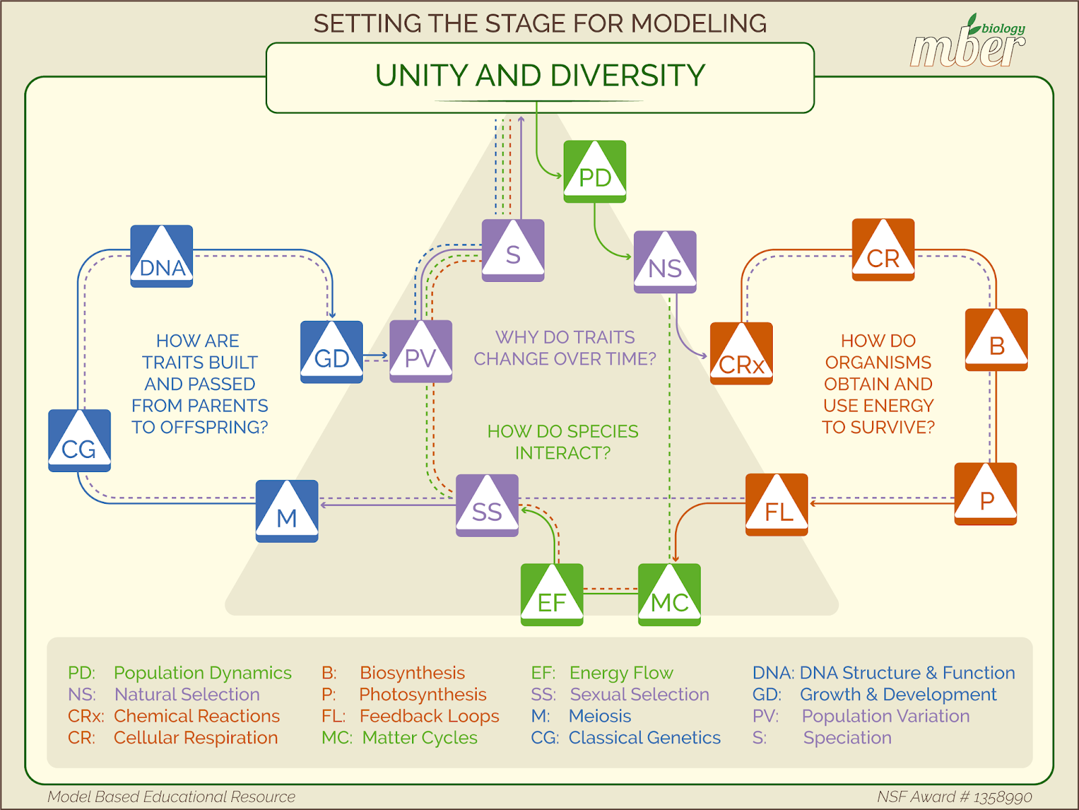

Tips for Success

Be on Time:
Learning is to begin when the bell rings. You will be marked tardy if you are not in your seat when the bell rings. Punctuality is a byproduct of responsibility and respect. Students who arrive on time perform better academically.
Focus:
Get off your phone during class. Students who do not use their phone in class (a major distraction) perform better academically.

Do Your Own Work:
Don’t cheat. Do your homework using the resources provided to you by your teacher and the textbook. Students who do their own work perform better academically.
Plan:
Be sure to give yourself time to complete your assignments and study material covered in class. This includes using your time in class wisely and reviewing periodically throughout a unit (rather than only in the last days leading up to a test). Students who consistently complete their work and review content periodically perform better academically.

Be an Advocate for Yourself:
Ask questions. Get explanations if you are unclear on due dates or if concepts are confusing. When you miss class, use the website to get yourself caught up. Use the supplemental resources provided to assess your own progress by asking yourself “Do I really understand this?” often. Students who advocate for themselves perform better academically.

Move from a “Fixed Mindset” to a “Growth Mindset”
Students who exhibit a growth mindset perform better academically.

Biology 1
Course Contract
Assignment 1

Parents and students please initial below: | Student  Initial | Parent  Initial
I know the PowerSchool username and password that allow me to access the
above student’s grades. I can access PowerSchool and view grades. If
unable to access PowerSchool due to internet connectivity issues, I
understand that students may request a printed grade report at any time.

I can access and navigate the website for Biology class. I understand
that instructor contact information, a daily agenda, due dates, all
assignments, class lecture notes, supplemental material and class policy
information can be found on this site.

I have read the course syllabus for Biology 1 and understand all rules and policies that pertain to this course.

Parent Name: __________________________

Signature: __________________________

Date: ______________________

Student Name: __________________________

Signature: __________________________

Date: ______________________

Hour: _____

